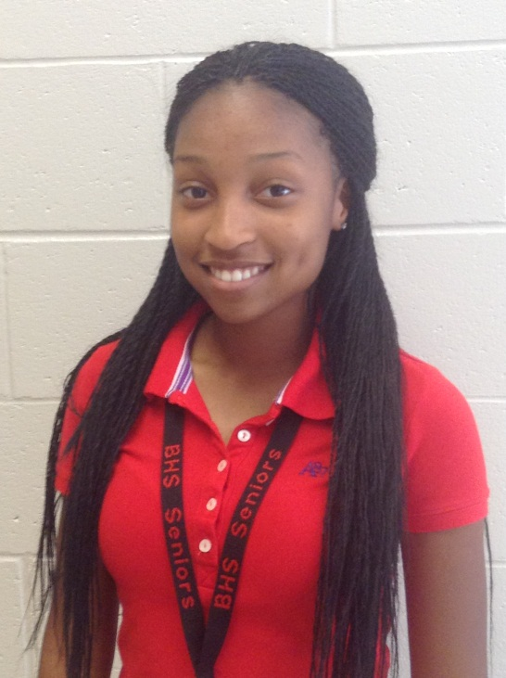

Hello my name is Cahliah Walker. I’m a senior here at Baldwin. Over the years my extra-curricular activities that I’ve enjoyed are running cross country and cheering. My first career goal is to become an obstetric nurse. This is my fourth year as a HOSA member. So far I’ve been nervous but very excited to be HOSA president this year. Now enough about me let’s talk about HOSA.

Since being started in November of 1976, HOSA had gradually grown reaching nearly one-hundred twenty thousand members as of year 2009-2010 through forty seven chartered HOSA State Associations. Over ten thousand members are in Georgia, ranging from middle school, high school, and post-secondary to community chapters. Equaling a total of at least two hundred nineteen active charters that are letting their objective, just the same as ours, be known through dedication and action. The mission of HOSA is to enhance the delivery of compassionate, quality healthcare by providing opportunities for knowledge, skill, and leadership development of all science education students, therefore, helping the students meet the needs of the healthcare community. With that said, as of now my job is to state the standards on where we stand. It’s up to us as a whole to come together and build our HOSA chapter a better, stronger, and wiser Health Occupational Students of America.



Our HOSA chapter has accomplished some amazing objectives our natural talent has allowed us to do over the years. One to start us off is the Special Olympics hosted in Milledgeville once, and Statesburo and Macon twice. We attended them all. Our very own hosted in Milledgeville was great with a tremendous amount of volunteers. A lot of groups that had never helped before came out. There smiles and happiness filled in everywhere. I’m proud to say that Baldwin High’s HOSA was one of those volunteers April of 2011.

We have paid visits to see our senior citizens and have some fun. Playing games like bingo and simply lending an ear and warm heart to those that may have needed just that. I know in our future we will definitely keep that going. If only one smile is put on someone’s face at the visit that’s better than none at all with no time invested period.

I’m not sure if you all know but our HOSA chapter has qualified for Nationals twice. We went once to Texas and just knowing that I know we can do something to make that happen again or give it our all trying. This year I hope to see us volunteering, giving back, and competing more than ever before Recruit more and spread healthy knowledge all around. Together we can make our own dreams come true. Martin Luther King once said: IF YOU CAN’T FLY, THEN RUN, IF YOU CAN’T RUN, THEN WALK, IF YOU CAN’T WALK, THEN CRAWL, BUT WHATEVER YOU DO, YOU HAVE TO KEEP MOVING FORWARD. Baldwin High School’s HOSA let’s move forward to success!

