Baldwin College & Career Academy Students Attend State Leadership Meeting
by Javoris Goodman
Pictured left to right: 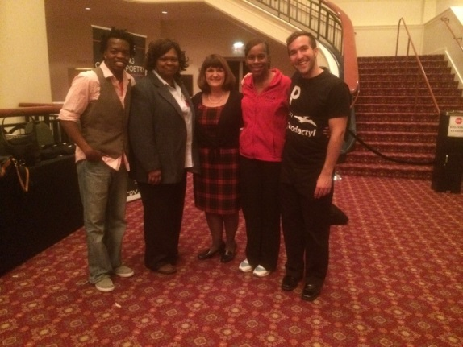
(Member of Cometry), Ms. Hardy, Dr. Wall, (Houston County CTAE Director of Career, Technical, and Agriculture programs)
Mrs. Rodgers and Chad Songy (Member of Cometry)
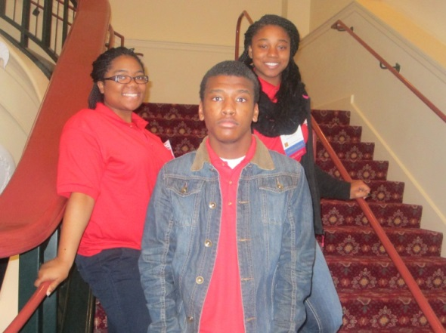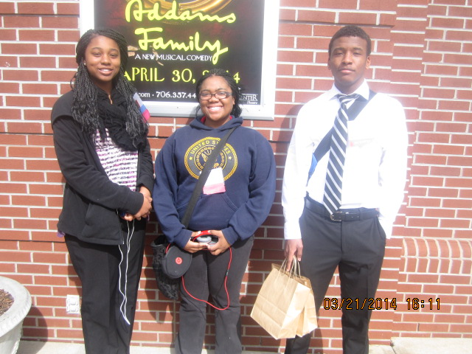
Pictured left to right: NaQuiria, centered Pictured left to right: DeAsia Wilson, NaQuiria Williams and Javoris Goodman
Javoris Goodman Williams and DeAsia Wilson

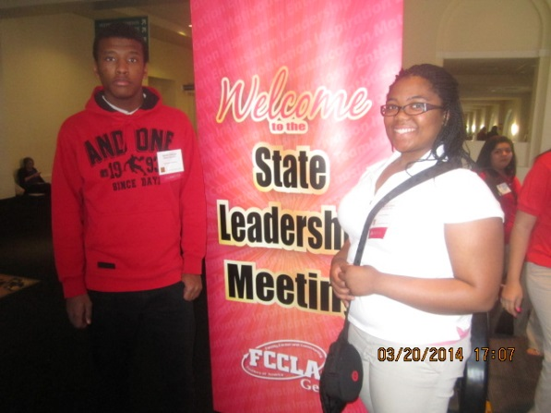
Pictured left to right: Javoris Goodman and NaQuiria Williams

Athens, GA is always painted red. However, this weekend, Athens went ”Code Red” as youth from the Baldwin College and Career Academy chapter of Family, Career and Community Leaders of America (FCCLA) participated in a weekend leadership conference held March 20-22 at the Classic Center. Red blazers took over the town as attendees participated in competitions, a Career and Trade Expo, University of Georgia Tours, educational demonstrations, and workshops and leadership sessions that challenged informed and motivated students and advisers with the theme, “Code Red.” This theme inspired leadership to the extreme for Javoris Goodman, DeAsia Wilson and NaQuiria Williams students from Baldwin College and Career Academy along with their Advisors Ms. Hardy and Mrs. Rodgers.
“Code Red” sounded at Thursday’s Opening and Business Session where the 2013-2014 State and Region Officers began the powerful and motivating leadership for the weekend. Students and advisers engaged in opportunities for learning, networking and growth. Many students competed in Students Taking Action with Recognition (STAR) Events competitions on Friday. These competitions were held in twenty-five areas showcasing the proficiency and achievements of members. Also, on Friday a Career and Trade Expo was held featuring exhibitors from colleges, fundraisers, businesses and industries associated with Family and Consumer Sciences, Culinary and Education. Le Cordon Bleu College even showcased their culinary skills in demonstrations for students.
Friday evening, a reception was held to honor administrators, special guests, award winners, and former chapter advisers. Following the reception, a Recognition Session was held for the awarding of Honorary Memberships and other awards to adults, school and student scholarships recipients. In addition, the 2014-2015 State Officers were announced.
Before ending Friday by dancing the night away at a gala, students experienced an exciting presentation by Cometry. Cometry used skills in comedy and poetry to teach leadership and values in a fun, relevant way. Students were engaged in the humor and excitement as cometry taught them the concept of “GRAV”: growth outside of their comfort zones, research and understanding, approachability, and validation of themselves and others in their community.
Friday’s events were exciting for the students to learn and do new things. They enjoyed comedy in the Classic Center Theater. The students learned not to be average but stand out, be goofy sometimes, ask questions, etc.
The State Leadership Meeting came to a close on Saturday beginning with a Spotlight on projects Walk-through that showcased outstanding individual and chapter projects. The STAR Event winners and the induction of the 2014-2015 State Officers. I truly enjoyed the conference and looking forward to attending more in the future. We had 1 of our members to make it to Nationals in San Antonio, Texas. Dominique Butts will be attending Nationals in July. She competed in FCCLA Chapter Website which she designed herself. View our website under BCCA and tab to the CTSO click on FCCLA you will see what a great job she did.

